Case Report - Distraction Osteogenesis

¹Dr Sonal Anchlia*, ²Dr Vipul Nagavadiya , ³Dr Jay Shah , ⁴Dr siddharth vyas , ⁵Dr Utsav Bhatt

¹MDS, FIBCOMS, oral & maxillofacial surgery, Head of department, dept. of oral & maxillofacial surgery, Government Dental College & Hospital, Ahmedabad, Gujarat, India
²Post graduate student, oral & maxillofacial surgery, Government Dental College & Hospital, Ahmedabad, Gujarat, India
³MDS, oral & maxillofacial surgery, Tutor, dept of oral & maxillofacial surgery, Government Dental College & Hospital, Ahmedabad, Gujarat, India
⁴MDS, oral & maxillofacial surgery, Government Dental College & Hospital, Ahmedabad, Gujarat, India
⁵MDS,Oral& Maxillofacial Surgery, Government Dental College & Hospital, Ahmedabad, Gujarat, India
Corresponding author*

ABSTRACT
Distraction Osteogenesis is a technique of inducing de novo bone formation by utilising bone’s ability to regenerate by controlled and gradual callus traction that forms between surgically osteotomized bone segments. One of its major advantages is simultaneous soft tissue (skin, muscle, and neurovascular structures) formation, which stabilizes skeletal reconstruction. We present the treatment of an adult patient who had severe mandibular deficiency & obstructive sleep apnea secondary to TMJ Ankylosis release. Bilateral Biplanar Distraction was performed with extraoral Distractors which resulted in drastic improvement in patients profile - ANB decreased from 22° to 11°, Ramal length increased from 25mm to 32mm, Corpus was lengthened from 34mm to 52mm, Overjet was decreased from 14mm to 9mm. Also, the pharyngeal airway space was improved significantly which was attributed to the anterior growth of the mandible. Chin augmentation as a secondary surgery with PTFE chin implant was performed after 7 months to correct chin deficiency post-distraction. Results were extremely satisfactory and stable both aesthetically and functionally even at a follow-up of 2 years.
KEYWORDS; Bilateral Biplanar Distraction Osteogenesis, Obstructive Sleep Apnoea, PTFE chin implant, TMJ ankylosis, Mandibular retrognathia

INTRODUCTION
Distraction Osteogenesis is a technique of inducing de novo bone formation by utilising bone’s ability to regenerate by controlled and gradual callus traction that forms between surgically osteotomized bone segments^{[1]}. One of its major advantages is simultaneous soft tissue (skin, muscle, and neurovascular structures) formation^{[2]}, which stabilizes skeletal reconstruction. We present the treatment of an adult patient who had severe mandibular deficiency & obstructive sleep apnea secondary to TMJ Ankylosis release. Bilateral Biplanar Distraction was performed with extraoral Distractors^{[3]} which resulted in drastic improvement in patients profile - ANB decreased from 22° to 11°, Ramal length increased from 25mm to 32mm, Corpus was lengthened from 34mm to 52mm, Overjet was decreased from 14mm to 9mm. Also, the pharyngeal airway space was improved significantly which was attributed to the anterior growth of the mandible. Chin augmentation as a secondary surgery with PTFE chin implant was performed after 7 months to correct chin deficiency post-distraction. Results were extremely satisfactory and stable both aesthetically and functionally even at a follow-up of 2 years.

BACKGROUND
Distraction was first thought of by Codivilla^{[4]} in 1905; after which Ilizarov established the foundation of Distraction Osteogenesis and its role in orthopaedic management. In 1973, Synder et al showed the application in craniofacial surgery. 20 years later, McCarthy and colleagues in 1992 reported the first case of mandibular lengthening in 4 children with congenital mandibular deficiency. Kaban et al^{[5]} provided definitive guidelines for the management TMJ Ankylosis.However, issues pertaining to secondary facial deformities and reduced nocturnal oxygen saturation levels continue to haunt both, patients as well as surgeons. For resolving these, much work has been done till date and various protocols have been formed. Orthognathic Surgery, Distraction Osteogenesis and Transport Distraction have revolutionised the management of these morbid conditions.To lengthen severely hypoplastic mandible involving corpus as well as ramus, Biplanar devices are preferred over Uniplanar devices for better control over the vector, when three-dimensional vector control is required and gonial angle control is necessary^{[1]}.The case here is presented with proposed treatment of Obstructive Sleep Apnoea Syndrome (OSAS) with severely deficient mandible by extraoralBiplanar distractors for the independent distraction of the osteotomized corpus and ramus bilaterally. Cephalometric analysis was done to measure the length of preoperative deficient and post chin implant after consolidation. Also, Pharyngeal airway space (PAS) was measured using cephalometry. CT scans were done to evaluate the amount of movement required and that achieved.

CASE PRESENTATION
A 15-year-old female patient reported to the Department of Oral & Maxillofacial Surgery at Government Dental College & Hospital, Ahmedabad with the chief complaint of difficulty in breathing during sleep, facial asymmetry, and retruded lower jaw.Thorough clinical history revealed the patient had a fall 10 years back. No definitive treatment was sought. Gradually she noticed a decrease in mouth opening, which ultimately led to complete trismus. As she grew up, mandibular growth was hampered and facial asymmetry in the form of micrognathia and microgenia started getting evident. She had undergone surgery to release TMJ Ankylosis 7 months back in another unit when the ankylotic mass was resected and bilateral gap arthroplasty was done. Adequate mouth opening was achieved and function of mastication was restored. However, the micrognathia was not addressed. Moreover, the bilateral gap arthroplasty led to a bilateral decrease of ramal length and the mandible falling back and hence, further compromise in pharyngeal airway space that was already scant by virtue of micrognathia secondary to TMJ ankylosis. Soon after the surgery, she started having episodes of nocturnal sleep apnoea leading to marked fall in oxygen saturation levels. This led to the poor quality of life aggravated by lowered self-esteem due to facial deformity.
At the time of presentation with OSAS, she had an extremely convex profile, with a severely retruded mandible and chin. Intraoral examination revealed arch length deficiency leading to palatoversion of left maxillary canine, mild rotation and labioversion of left maxillary central incisor, with proclined incisors. She had a full set of teeth in the maxilla and in the mandible on the right side she was edentulous, posterior to the second premolar. On the left side of the mandible, all teeth except third molars were present. Overall it was a case of severe Skeletal Class 2 growth pattern, with soft tissue depression over the ramus, a very obtuse neck chin angle and a very deep lower labiomental sulcus. Functional occlusion was present with minimal overjet and minimal occlusal cant.
Cephalometric analysis was done to analyse hard and soft tissue discrepancy, to measure the degree and amount of deficiency present and distraction needed. CT scan was done to aid in diagnosis,and to determine planned osteotomy site . Cephalometric results confirmed severe skeletal class 2 by ANB angle 22, and point A and pog ;10 mm and 43 mm posterior to NV.This showed a huge amount of mandibular discrepancy as well as mandibular retrognathism.Corpus and ramus measured 34mm & 25mm respectively indicating that were deficient.Y Axis 79° and increased Gonial angle and mandibular plane showed a posteriorly rotated mandible.Jarabacks ratio of 49.5% indicated a long face which was due to increase anterior facial height as well as decreased posterior facial height of 99mm& 49mm respectively. This all warranted the use of bilateral extraoralbiplanar distractors for increasing bilateral length of the corpus as well as ramus while maintaining gonial angle control.

INVESTIGATIONS
- OPG (Orthopantomogram) showed severely deficient ramal height on both sides in temandible.
- CT scan (Axial, coronal, sagittal with 3D reconstruction)served to plan osteotomy cuts and visualise the degree of deficiency with posteriorly rotated mandible, deficientramal and corpus length.[figure ]
- Haematological examination(HB-11.5gm, CT-4 min, BT- 2min, RBS-126mg/dl).All other major preoperative investigations were within normal limits.
- PA Cephalogram aided in measuring the height of corpus, ramus and deviation of chin towards right side by 8mm.
- Lateral Cephalogram served as one of the most important investigation of almost every aspect of hard and soft tissue analysis of the patient. This remains our main measurement tool for PAS as well which was extremely small measuring only 1.9mm.[table 1 & table 2]
- Polysomnographywas done preoperatively to asses multiple nocturnal desaturation episodes(lowest was 59%) and to determine postoperative improvement. It turned out to be a severe score of obstructive sleep apnea syndrome with Apneic-Hypopneic Index (AHI)-56.2^{[6]}.
- Articulated Casts for assessment of occlusion and planning osteotomy cuts and jaw relations.
- It is better to plan such cases with the stereolithographic model but due to poorsocioeconomic status of the patient , we would not be able to do this.

DIFFERENTIAL DIAGNOSIS
As the patient had a history of gap arthroplasty 7 months back and was presented with difficulty in breathing during sleeping, it was an obvious case of Obstructive sleep apnea secondary to TMJ ankylosis release with clinically severe retrognathia. Furthermore, cephalometric study and polysomnography confirmed our diagnosis.

71
TREATMENT
As the patient refused to undergo any pre/post surgical orthodontic treatment, aesthetic correction along with the improvement of airway space had to be done by surgical correction itself. Moreover, as the patient had a deficientramal height as well body length measuring 25mm,34mm from Lateral cephalogram, Uniplanar distraction could not have sufficed control of vector and gonial angle, which was of utmost need. Also, the case was beyond the scope of orthomorphic and orthognathic surgery. Hence after thorough clinical, radiological and cephalometric analysis, the decision of using extraoral Bilateral Biplanar distractors was inevitable and unanimous.
Significantly compromised posterior pharyngeal space(PASmin)1.9mm with a previous history of tracheostomy ruled out nasotracheal, orotracheal, fibreoptic or submental intubation. An elective tracheostomy was a must in this case.Preoperative preparations were done and NBM guidelines followed.Informed consent for surgery and tracheostomy was taken.Premedications were given half an hour before surgery were inj.augmentin 1.2 gm iv in 100ml NS,inj metronidazole 500mg iv,inj. Dexona 8mg iv.inj pantoprazole 40 mg iv,andinj.T.T. 0.5 mg IM.
Surgical Procedure:
After painting and draping of the patient, tracheostomy was done under local anesthesia without any sedation.The airway was secured and optimum oxygen saturation level achieved and maintained.The localanesthetic solution, Lignocaine with Adrenaline in the concentration of 1:100000 was diluted in normal saline and injected at the surgical site. Risdon’s incision was given. Layerwise dissection was done. Vital structures were preserved and bone was exposed.
Two osteotomy cuts were given. one on the ramus and the other on the body region, bilaterally. The gap between the two cuts was kept 2-2.5 cms to prevent necrosis of the intervening segment. Keeping angle as the center, buccal cuts were given first. Small osteotomes were used to osteotomies the segments and extreme care was taken to preserve the lingual periosteum. With the help of six Schantz’ pins on each side ( Two in each segment), biplanar distractor was placed and secured in position.The parallelism between pins of the same segment was maintained and fit of the distractor was checked. Care was taken not to damage roots of any teeth in the left body region. After final splitting with Smith’s spreader, activation of the distractors was done on both sides to make sure the osteotomy cuts were complete and the segments were able to get distracted without any encumbrance. Layerwise closure of the surgical site was done with Vicryl 4-0 (2304) and skin sutures were taken with 5-0 Ethilon (3320).
Post-operative care:
Proper post-operative care was taken. Tracheostomy closure was done on 4th day. Surgical site and distractors were left undisturbed for a week. After one week, distraction was initiated bilaterally. Distraction was done twice a day at the rate of 1mm/day. A total of 14mm distraction was done over right ramus region, 16mm over right body region and 20mm distraction was carried out over left side body and 20mm over ramus. Total distraction of 70 mm was achieved. Guiding elastics were given over the anterior teeth region after 10 days of distraction for callus moulding to prevent the anterior open bite.
To err on the cautious side, considering the magnitude of distraction, a consolidation period of 5 months was observed. CT scan was taken at the end of this consolidation period which demonstrated the formation of the bone overt distracted part to a satisfactory level. Removal of the distractors was done under local anesthesia without any difficulty.
72
OUTCOME & FOLLOWUP
After complete distraction, there still seemed to be scope for chin augmentation for the even better esthetic outcome. It was executed under local anesthesia by an intraoral degloving incision and placing PTFE implant, securing it with the help of a single screw. Surgical site was sutured with 4-0 Vicryl (2304) and it healed uneventfully.(patient refused for general anaesthesia for advancement genioplasty to correct the residual chin deficiency)
Results were stable even after 2 years
On account of distracting right ramus 14mm, body 16mm; left ramus 20mm, body 20mm, a total amount of distraction done was 70mm.
Thereby increasing Ramal length(Ar-Go) on average of right and left rami as with cephalometric analysis of lateral ceph by 8mm.[Normal ramus height in female is 46.8 +/- 2.5 mm] and average corpus length(go-gn) by 18mm ,normal of which is 74.3+/- 5.8 mm⁽⁸⁾.
Posterior Airway Space at PASmin was increased by 4mm.
AHI was decreased from 56.2 to 14.3 which is transition from severe to mild, after complete distraction.
Nocturnal desaturation episodes were decreased significantly thereby giving a better quality of sleep, eliminatingdaytime somnolence and overall improvement of the quality of life which boosted patient’s self-confidence.
Complications to note were inevitable facial scarring due to extra-oral distractors,residualopen bite of 2mm, transient mental nerve injury
DISCUSSION
Morbidities associated with TMJ ankylosis continues to haunt both, patients as well as surgeons. It is quintessential to have a tailor made management strategies for each individual. Well formulated treatment plan must be aimed at addressing patient’s chief complaint and restoring them to the normal level so much as possible.
Distraction osteogenesis has been a path breaking advancement in the field of Oral & Maxillofacial surgery. Originally described by Ilizarov^{[9]}, many modifications and refinements have been made for their application in the field of maxillofacial surgery.
Uniplanar distraction can be done at the ramus or body. However, in this caseramal height was also short. Had we performed uniplanar distraction by giving osteotomy cut at the angle region, growth direction would have been vertical resulting in an extremeopen bite. Callus moulding is the only non-invasive method for correcting such open bite. However, it is not possible to rectify open bite of such extent only with callus moulding. This would have necessitated another surgery. Hence biplanar distraction was warranted in this case.
One of the biggest risks in biplanar distraction performed with two osteotomy cuts is the avascular necrosis of the free segment if lingual periosteum is not handled carefully. And in such cases, results can be disastrous. Hence biplanar distraction with just one osteotomy cut is usually performed. The chief concern with this safer method is once we initiate the distraction, ramal part gets distracted first and moves into the gap created by ankylosis release and only after that the distal segment goes down. This may lead to reduced mouth opening and re-ankylosis. However, the biggest concern here is losing control over the vector. Hence, the decision to place two Osteotomy cuts was made.
Though distraction was complete, in post-operative CT scan left side body distraction seems to be less significant. We can attribute this to the callus moulding done for anterior open-bite.
Also, recently there has been an extensive emphasis over obstructive sleep apnoea which was neglected to some extent in the past. However, with recent concepts emerging, it is evident that obstructive sleep apnoea needs to be addressed with equal importance. Besides nocturnal desaturation episodes, a patient may not be able to perform post-operative mouth opening exercises as already compromised posterior pharyngeal airway space further worsens when mandible slides downwards and backwards. Andrade et al^{[10]} have come up with a definite management protocol in patients presenting with triad of TMJ ankylosis, micrognathia and obstructive sleep apnoea, wherein a particular age group of cases, distraction pre-ankylosis release has been advocated
73
The concept of transport/bimaxillary distraction osteogenesis⁽¹¹⁾ also seems to be promising in the management of such patients. Karim et al demonstrated successful biplanar distraction to lengthen hypoplastic mandible. Treatment of TMJ ankylosis and facial asymmetry with biplanar transport distraction osteogenesis has been successfully demonstrated in a series of patients by Eski et al⁽¹²⁾ .
These treatment modalities can always be supplemented with procedures like genioplasty or chin augmentation with the help of alloplastic implants. They may help in enhancing outcomes to even better magnitude. In our case, chin augmentation was done with the help of thermoplastic Polytetrafluoroethylene implant of dimensions 38mm*50mm*6mm . Edges were smoothened and trimmed and the implant was secured with the help of one screw. In this case, extended genioplasty would have been an excellent option. Also, soft tissue predictability of osseous genioplasty is better in comparison with alloplastic augmentation. But, more invasive nature of osteotomy in case of osseous genioplasty leads to the potential for more complications, more significant swelling and longer postoperative recovery[13]. Also, it would have necessitated surgery in general anaesthesia. Hence, alloplastic implant was preferred as the patient refused to general anaesthesia.
Highly satisfactory results were obtained in our case of bilateral micrognathia, microgenia and obstructive sleep apnoea with the help of bilateral biplanar distraction osteogenesis followed by chin augmentation with PTFE implant. With a well-formulated treatment plan, we were able to restore form, function, aesthetics and psychological status to the optimum. Two yearsfollow up pictures reveal minimal relapse.
CONCLUSION
- Post TMJ ankylosisrelease,Severlyhypoplastic mandible with severe OSA with deficient ramal-corpal length requires treatment with extraoralmultiplanar distractor.
- Better vector and gonial angle control is provided by biplanardistraction,using two osteotomies and preservation of lingual periosteum.
- Callous moulding is essential and can be carried out by giving box elastics in anterior teeth. It has definitely served as an alternative method to reduce theangle of distractor but was not as efficient.
- PTFE chin implants offers a good alternative to Genioplasty for chin augmentation if OSA is not a concern even after distraction.
- At last,patient satisfaction and better quality of their life is in centre with willingness for surgery and treatment options remains important.

74

ACKNOLEDGEMENT:
Sincere Thanks to Dr PriyankaRaiyani& Dr RamyataDayatar for thier efforts in collecting essential data for the publication of this case report, Dr Hardiksuvagiya& Dr NisargYagnik for helping out in cephalometric assessment and case analysis in a view of an orthodontist, Dr Nisarg Patel, Dr RohitParmar& Dr Dhruvi Shukla for being excellent colleagues & critical reviewer of this paper.
REFERENCES
1.Samchukov ML, Cope JB, Cherkashin AM: Craniofacial distraction osteogenesis. St.Louis: Mosby; 2001.
2.Klein C, Howaldt HP: Correction of mandibular hypoplasia by means of bi-directional callus distraction. J CraniofacSurg1996, 7:258-266
3.KerimOrtakoglu, SenizKaracay, MetinSencimen, Erol Akin, Aykut H Ozyigit and Osman BengiDistraction osteogenesis in a severe mandibular deficiencyHead & Face Medicine 2007, 3:7
4.Codivilla A: On the means of lengthening, in the lower limbs, the muscles and tissues which are shortened through deformity. ClinOrthopRelat Res 1994, (301):4-9.
5.Kaban LB, Perrott DH, Fisher K. A protocol for management of temporomandibular joint ankylosis. J Oral Maxillofac Surg 1990; 48: 1145.
6. AASM (2001). The International Classification of Sleep Disorders, Revised. Westchester, Illinois: American Academy of Sleep Medicine,. pp. 58–61.
7.https://en.wikipedia.org/wiki/Obstructive_sleep_apnea#Diagnosis
8. Surgical correction of facial deformities,Varghesemani,page no 46
9. Ilizarov GA: Basic principle of transosseus compression and distractionosteogenesis. OrthopTraumatolProtez 32:7, 1971
10. N. N. Andrade, R. Kalra, S. P. Shetye: New protocol to prevent TMJ reankylosis and potentially life threatening complications in triad patients. Int. J. Oral Maxillofac. Surg. 2012; 41: 1495–1500.
11. Bimaxillary distraction technique for the correction of postankylotic asymmetry Egyptian Journal of Oral & Maxillofacial Surgery: October 2011 - Volume 2 - Issue 2 - p 59–67
12. Eski M¹, Deveci M, Zor F, Sengezer M..Treatment of temporomandibular joint ankylosis and facial asymmetry with bidirectional transport distraction osteogenesis technique. J Craniofac Surg. 2008 May;19(3):732-9.
13. Shadab Mohammad, Chandra DharDwivedi, R. K. Singh, Vibha Singh, and U. S. Pal. Medpore versus osseous augmentation in genioplasty procedure: A comparison. Natl J Maxillofac Surg. 2010 Jan-Jun; 1(1): 1–5

PATIENT’S PERSPECTIVE
I came to hospital because I was not able to sleep in since 7 months. I had lost my self esteem because of ugly face & nocturnal awakenings. After getting operated I am alright,satisfied with my look and now I do not wake during sleeping.
This Surgery has proved to be a been a boon for me specially in terms of my psychosocial well being.

75
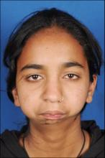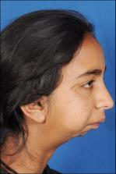

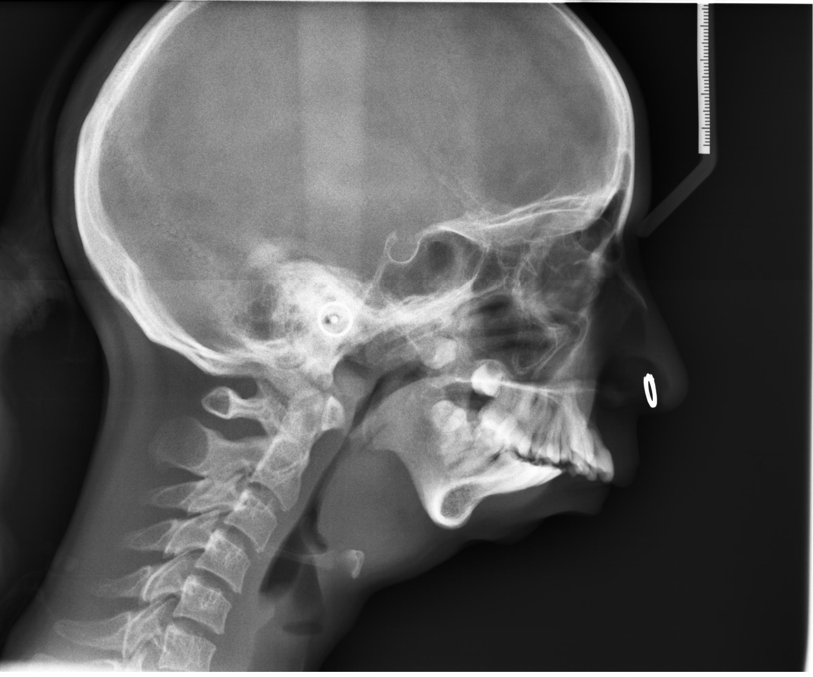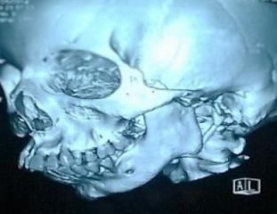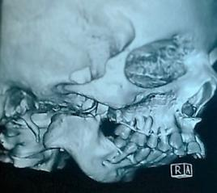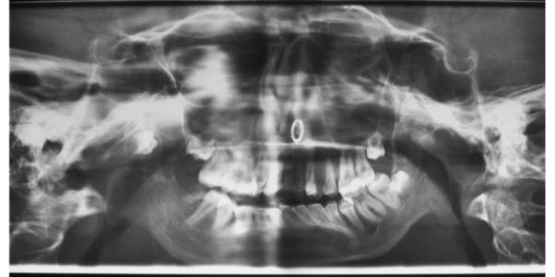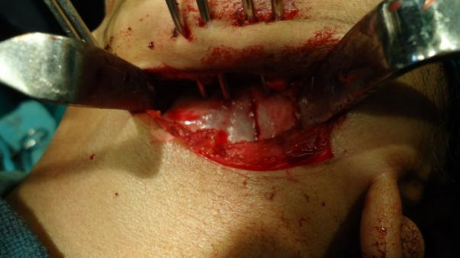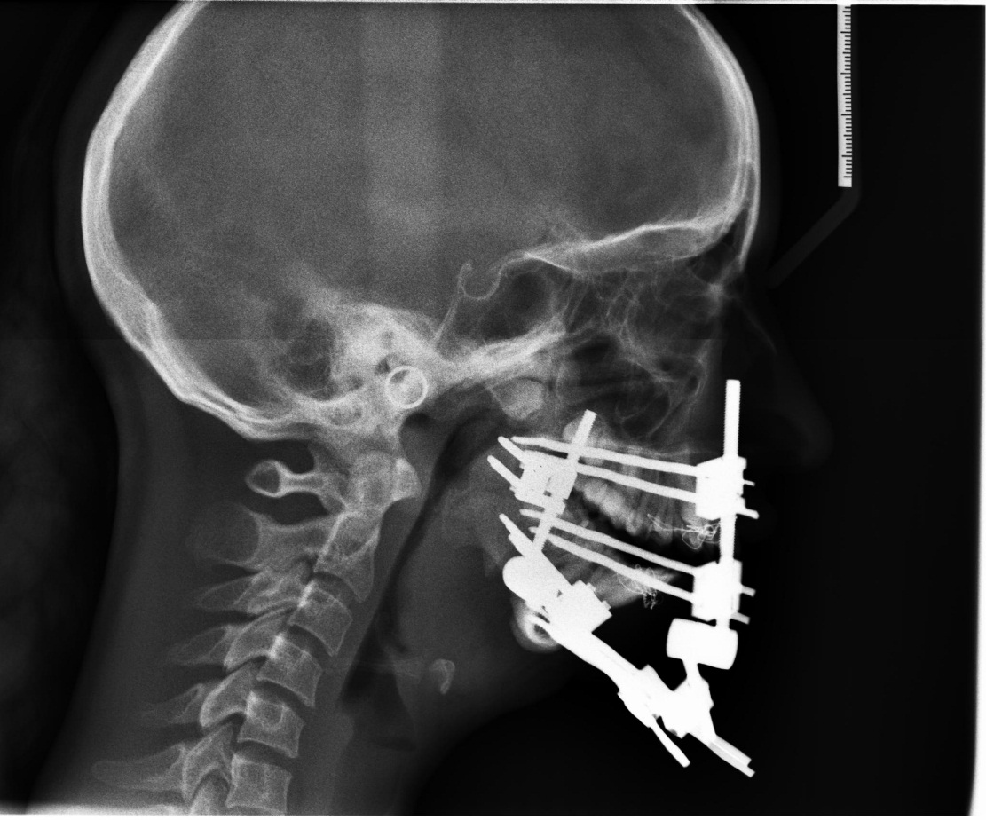
76
77
78
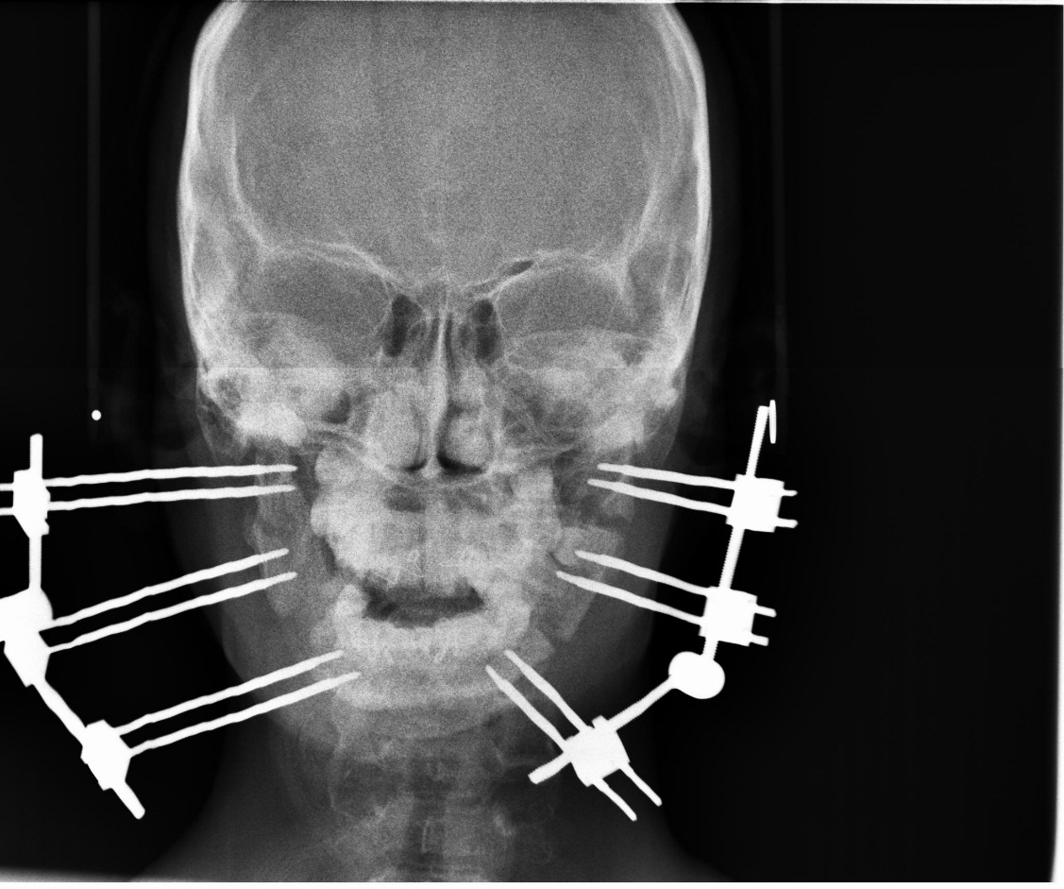
TABLE 1-Cephalometric analysis of patient
SNB | 55 | 61
ANB | 22 | 11
NV-A | -10mm | -10mm
NV-Pog | -43mm | -32mm
S-N | 71mm | 71mm
NSAr(saddle) | 107 | 104
SArGo(articulare) | 160 | 178
ArGoGn(gonial) | 137 | 144
Ar-Go(Ramal Length) | 25mm | 32mm
Go-Gn(Corpus Length) | 34mm | 52mm
Y Axis | 79 | 77
SN/ANS-PNS | 9 | 10
SN/Occ. ° | 44 | 32
SN/Go-Gn | 58 | 66
ANS-PNS/Go-Gn | 47 | 57
N-Me | 99mm | 120mm
N-ANS | 54mm | 54mm
ANS-Me | 47mm | 53mm
S-Go | 49mm | 56mm
S-Go/N-Me(jaraback) | 49/99*100=49.5% | 56/120*100=46.67%
Overjet | 14mm | 9mm
Overbite | -6mms | -4mm(openbite),1mm
SNA | 77 | 77
E line | -7mm/-8mm | +1mm/+1mm
79

